Outcome / Indicators | Content / Learning Experiences  Kindergarten Unit lesson plan utilising 8 Ways, ‘Super Six’ and Quality Teaching strategies. | Strategies | Assessment
TES1.2:  listens and contributes to class discussions on various topics  expresses a personal point of view and listens to the viewpoint of others  VAES1.2:  explores the qualities of paint, recognising qualities such as transparency and opacity and uses  brushes and other tools, eg sponges, rollers, scrapers to apply paint to different surfaces to create  textures, patterns, areas of colour  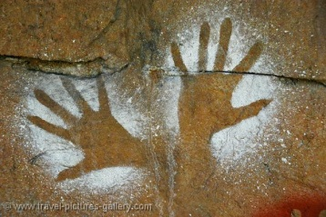  TES1.4:  practises clear articulation before taking part in recitation or role-play activities.  DRAES1.1:  works with other students and the teacher to develop dramatic situations in the drama forms of  improvisation, movement, mime and storytelling  WES1.9:  writes simple responses to short stories,  uses some stages of narrative, eg orientation,  complication | Introduction: Belonging, Community, Home  Read the text ‘Belonging’ by Jeannie Baker.  The window can be a reflective and thoughtful device through which we can examine our feelings about the land immediately surrounding our home and how we connect to it or belong to it. Jeannie Baker invites us to explore the concepts of ‘home’ and ‘belonging’ from this viewpoint. Get students to brainstorm the meaning of the word belonging. Ask what the idea of belonging means to them? Draw or list words that reflect your ideas.  Take students outside to a peaceful part of the school garden to read Jason Tamiru's poem and invite responses from the class.  Home by Jason Tamiru (2003)  My home is my past, my present, my future  My land, my home  Every tree earth water animals air  Everything that has been created is my tradition  Home is powerful  Home is comfortable  Home is Yorta Yorta land  My life.  Laying your hands on the earth is one way of expressing your belonging to the earth. Look at how handprints and other symbols are used by Indigenous Australians in their art to express their sense of belonging. Students use paint to create their own symbols that represent a connection to their home or family.  Lessons based on Jeannie Baker’s ‘Belonging Education Kit’  Caring for the environment  The animals in ‘Belonging’ are affected by changes to their environment. Choose an animal and look at the ways change to their environment effects them. It could be an animal facing extinction. Tell stories or use role-play of your animals, include the risks to your survival, your everyday challenges and how you overcome them.  Our school might be home to many creatures and provide food and shelter to many others. Use the following questions to encourage observation and exploration. What creatures live here at school? Are they native or introduced?  Which parts of the school do/don’t they like to be? Why/why not?  How do they use plants to survive? How do plants rely on animals for their survival? What else do they need to survive? As a whole class, make a map of the school marking in where different animals are found including the children’s observations.  Explain to students that by discovering what the animals need to survive we can find out how to improve our school ground for them. Brainstorm and research ways to improve the school for indigenous animals.  Students write and draw a retell of the story of “Belonging” in their own words and using pictures to depict the main events of the story.  Lessons based on Jeannie Baker’s ‘Belonging Education Kit’ | Land Links  Symbols and Images  QT: Engagement, Cultural Knowledge, Narrative  Super 6: Making Connections  QT: Background Knowledge  Story Sharing  Super 6: Questioning  QT: Connectedness, Narrative  Learning Maps | 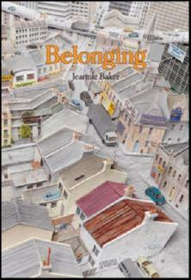  Observe how students contribute ideas during class and group discussion, and follow simple instructions.  Reflect on how students retell what they have heard and ask and answer simple questions for information and clarification.  Analyse students’ work samples to determine if students were able to identify one or two events from the story and independently write sentences using punctuation.

