Kathryn Gersbach

Unit/ lesson plan utilising 8ways framework

Stage: 2 – Year 3: Visual Arts/Indigenous Symbols |  |  | Date: Monday 3rd May 2010: |  |  | Duration: 50 min
Unit/Lesson Title and Objective: Retelling events in Aunty Wendy’s song ‘Until The Fire Is Out’ using traditional Aboriginal symbols and painting to create a headdress of significance. |  |  |  | Language: Symbols, bird’s eye view, warm earthy colours, circles, lines, curves, stories, art making and appreciating and visual recount
Rationale: After engaging with the community (and an Elder) and the classroom teacher I decided to plan an integrated creative arts and visual literacy experience to link in with a community project and for the class to explore Indigenous culture since 70% of the students were from Indigenous backgrounds, struggling with literacy comprehension activities and have had limited opportunities to engage in learning related to their cultural identity (Jordison, S,. personal communication April, 2010); (Reed, T,. personal communication, March, 2010 ). The visual arts are integral to the expression of Aboriginal cultural identity and the contemporary interpretations of Indigenous experiences. Through this experience of deconstructing and reconstructing (retelling) the story depicted in a local elder’s song ‘Until The Fire Is Out’ and by interpreting this on a headband using symbols to link with an upcoming dance performance, students can focus on the subject matter of works, the techniques artists use and the meanings (comprehend using symbols) that the works may generate. Therefore making art works of cultural significance that are linked to other areas of learning provides students with opportunities to make artworks about different investigations, to look at, talk about and appreciate art works of others and their own. |  | Syllabus Outcomes & Leaning focus /Indicators:  Making  VAS2.1 Represents the qualities of experiences and things that are interesting or beautiful by choosing among aspects of subject matter.  - Seeks to investigate traditions in art suited to different subject matter, the use of Indigenous symbols (most being from Wiradjuri Country) and uses these in their art making.  VAS2.2 Uses the forms to suggest the qualities of subject matter.  - Experiments with techniques in painting, drawing and uses the artistic concepts of patterns, colour, shapes, line and bird’s eye view perspective.  - To explore how symbols may be used in their interpretation of selected subject matter.  Appreciating  VAS2.4 Identifies connections between subject matter in artworks and what they refer to, and appreciates the use of particular techniques.  - Identifies Indigenous symbols in painted arts works and artworks of their own. |  |  |  |  | Links to other KLAs:  - HSIE: CUS2.3 Indigenous Culture.  - Music/singing: MUS2.1 visual colour patterns, lines and shapes.  - PDHPE: COS2.1 Group work and respect, demonstrates communication skills.  - English: Retelling stories of significance, visual literacy, Reading viewing, talking and listening see syllabus for specific outcomes.  Extension:  Write a recount/procedure of the steps taken to paint their head band in symbols and or describe and write in a journal entry about what they liked the most and why.  Remediation:  Visual smart board image & One to one assistance for special needs (aide) and students struggling with the concept.
Prior Knowledge:  Some basic knowledge of Aunty Wendy’s song “Until the Fire Is Out” | Risk Assessment:  Make any adjustment for the special needs by consulting with the associate teacher prior to and during the lesson. Safety rules when using sticks and paint eg hands to one’s self and painting smocks to protect clothing. | Resources:  - Note book, Smart board and internet link to Art gallery + Artefact (painted head band) + Aunty Wendy’s CD-school resource  - 30 fine brushes, match sticks or paddle pop sticks & material strips.  - Earthy coloured paints, red, yellow, black, brown, green, blue and paint pots. |  |  | - Copies of Art works by indigenous artists  - Images of symbols & Paper to practice on. Paper printouts of symbols (story)  - Whole group floor and small group table space and paint mats and students painting smocks.

Planning/ Implementation/Evaluation of Teaching Experience
Time | Content/Learning Experience | Organisation/strategies & Q’s | Assessment
5 min  8 min  8 min  25 min  10 min | Introduction:  - Introduce the lesson by playing Aunty Wendy’s song “Until the Fire Is Out’. Explain objectives Today we will be “Retelling Aunty Wendy’s song ‘Until the Fire Is Out’ using traditional Aboriginal symbols and painting to create a headdress of significance” to wear in our performance at the Coo-ee lodge.  - But first we will identify traditional Aboriginal symbols used to tell stories in paintings, then we will identify some of those symbols in art works and then we will talk about the symbols that retell the song we have been learning.  - Ask students to recall the major events that happened in the song.  Body:  - Explain to the children that aboriginal paintings tell dreamtime stories and are also used to give directions using symbols that are significant to them from a view that looks down on the land from the sky.  - View slide 2: discuss the colours and shapes found in the paintings.  - View the Gallery encourage students to take notice of the colours lines and shapes in the patterns http://www.aboriginalartshop.com/  - View slide 2: discuss some of the symbols in the paintings and what they might mean by questioning students and acknowledge their answers with encouragement “great observation skills etc”.  - View slide 3: discuss the symbols and ask students what the symbols might mean and if they could be used to retell particular events identified in the discussion. E.g. Emu symbol resembles an emu footprint.  - View slide 4: explain we will be making a visual recount of the main events in the song using aboriginal symbols. Have randomly selected or pairs of students to move the symbols to match the words. When complete have the students as a class read through the reconstructed symbol (visual) recount.  - View slide 5: explain we will be painting and recreating the recount of symbols of significance on a head band for their performance. Show the students pictures of different head-dresses worn in indigenous dances highlighting the use of symbols. Then have randomly selected students or pairs of students to have a go at drawing some of the symbols from their recount on the smart board to practice.  - Demonstrate painting one of the harder symbols /students practice on paper.  - Commence Painting their headbands and provide feedback to the students.  - Pack up and have students seated on the floor for reflection time.  Conclusion: Have student explain which symbols they used and why, then conclude by singing the song ‘Until the Fire Is Out’. | Students on the floor  (whole class) Q. Put your hand up if you can recall one event that happened in the song? -then select students to share.  Examples of questions:  What colours have been used and why might they have been used?  What shapes have been used and why might they have been used?  Are they straight lines or curved?  Strategies: Explain, include technology, Question, encourage, instruct, demonstrate (model), and provide assistance.  8 ways strategies: deconstruct/ reconstruct the song, Using symbols and visual storytelling  Select students for interactive smart board and your turn slides. Ensure every student interacts with at least one of the interactive components.  Ask students to return to their desks desk in (table groups)  Move around the room and use one-to-one group scaffolding and encourage and comment on the beautiful art works headbands  Students on the floor  (whole class) | Watch for student’s engagement  Observe students’ responses.  Continually evaluate How well students share their thoughts on ‘topic’  Note students responses and stated complications ask each table what how and why they have represented symbols  Reflect on the depth of learning from students who clearly discuss implications  Summative Work sample and final product Marking eg.  - Use of symbols:  - In the correct order:  - Use of colour: Use of line.

Lesson and Resource Evaluation Summary
Were Objectives Achieved/developed? | Resources
See photos of work samples and the associate teacher’s comments attached.  - All students painted a recount using visual symbol representation (line, colour and curves) mostly in the correct order of the events in the song. (Observation: A couple of the students noted they had left out symbols which acknowledged their understanding of the task and reflects their learning.  - Class discussion: Every student participated at various times during discussions relating to art works from the internet virtual gallery and the visual images presented in the notebook presentation. (Observation transcripts. “Looks like a circle and the colours are brown and yellow”)  - The interactive smart board component: every student participated in the interactive component of matching symbols and or the ‘your turn’ to draw a symbol note book slide.  - This experience catered for individual differences and special needs by providing hand over hand assistance from the teacher’s aide for the student with a disability and the fact that this experience was planned to cater for those students with limited knowledge of indigenous culture and that experience literacy difficulties.  - All students were fully engaged (Observation: all students had their eyes on me during the discussion and the technology provisions when required).  - This experience was both age appropriate and interactive as it included discussion for depth, interactive smart board activities and hands on individual painting at small group tables by interpreting indigenous symbols and representing a visual recount of a known song to assist comprehension skills in a fun and engaging way and by applying the concepts of the eight ways of learning. Since, symbol, image and metaphor are central to Aboriginal pedagogy. Symbols and Images utilises all the senses to build symbolic meaning in support of learning new concepts in classes, involving the use of both concrete and abstract imagery, since students are primarily visual-spatial learners (Egan, 1998; as cited in 8 Aboriginal Ways of Learning, 2010). Story-sharing: This element is about grounding school learning in all subject areas in the exchange of narratives. Narrative is a key pedagogy in education for students of all cultural background (Hughes, 1992; as cited in 8 Aboriginal Ways of Learning, 2010). | Were they appropriate? Why/why not?  - The interactive smart board note book presentation provided a visual interactive component that enabled the depth of the creative arts and the indigenous cultural experience to be understood. For example the students were fully engaged with the virtual tour of the indigenous art gallery and were enthusiastic to participate in answering questions during the discussion time, matching the symbols to words and practicing symbol drawing on the smart board before attempting to paint them.  - The headband artefact enabled students to see what was actually expected as many indigenous students need to see the whole picture before they can begin to deconstruct and construct their knowledge understanding and skills (Harrison, 2008); (as cited in 8 Aboriginal Ways of Learning, 2010). Since many of the students wanted to refer to the example for guidance as a scaffold (Observation e.g. “Mrs Gersbach can I have another look at the headband so I can see what to do”)  - By using paint, match sticks and paddle pop sticks students were able to apply traditional painting techniques using modern equipment to give modern day relevance to a traditional cultural art (Observation: Students were able to manipulate the stick after the demonstration and practice time to reflect likeness of the symbols).  - The provision of whole group floor space was effective for the class discussion as distractions were limited. The group table work was effective as this encouraged talk and discussion relating to the symbols, order and paint colours they were using (Observation transcript: “I am going to paint the fire red because red means hot”, “my emu feet are brown because they are in the dirt”, I have painted my sun yellow because the sun outside is yellow”).  - The timing of the lesson was perfect as the associate teacher commented (see associates evaluation attached). The lesson did not demand students to rush and allowed time for more detailed workers to complete the task (Observation: many of the students were taking care to do their best work by not rushing).  - Improvements would include inviting a local artist in to demonstrate painting the symbols rather than relying on my inexperienced efforts and providing more of the local history of symbols used rather than relying on commercial reproductions.

Lesson and Resource Evaluation Summary
Strategies, Questions, Interactions | Assessment
Were they appropriate?  - Firstly by asking the students to put their hand up if they could recall the events in the song, I established the ground rules for the discussion, whereby the students responded by not calling out and waiting for me to select them to answer, in which I learnt those of who had prior knowledge of the events in the song.  - Secondly by explaining, modeling and demonstrating how to identify colour, shape and line in the art work collection on the smart board and then by asking questions to determine their knowledge of colour, shape and line relating to the paintings and virtual gallery works I was able to determine who had grasp the concept. (Students responses: brown, yellow, orange, blue, green, circles, dots, straight lines, curved lines and animal foot prints).  - I had clear intended outcomes that enabled me to remain focused on the task at hand, students generally understood what was expected of them as I made it clear in the lesson introduction.  - By integrating multiple media including interactive smart board activities to teach the less exciting content and questioning the students during discussion time I managed to maintain their engagement and kept all students involved in the topic. This was one of my lessons strengths as the associate teacher noted in her evaluation of this lesson (see associates evaluation attached).  - Due to the fact that the students were engaged for the entire duration of the lesson I did not once have to stop to address any inappropriate behaviour.  - There were minimal pauses and because I was organised and knew what I was teaching, students weren’t given an opportunity to disengage, they were kept busy and involved in learning throughout the lesson.  - All students responded well to my encouragement and acknowledgement of their work and in return were safe respectful learners. | Were they appropriate? How did this assessment cater for special needs in the class  - Class discussion: was effective as it highlighted what the students already knew (Observation: one student was familiar with a couple of the symbols and was eager to share that knowledge the other students were keen to listen to that student’s knowledge).  - Interactive smart board activity: was effective as I was able to assess the students understanding of events that happened in the song and their ability to draw the symbols. There was not one child that did not achieve the intended outcome as the modeled, guided and independent assessments throughout the lesson enabled me to evaluate whether they required any added assistance for those with additional needs to grasp concepts in which were not needed as the guided activities provided ample opportunities for the students to grasp the concept of retelling the song through symbols and practice applying that knowledge.  - How did the summative assessment assist teaching? The student work samples: Song retold using painted symbols on headbands to use as a dress accessory for a dance they will be participating in the near future. Most students used appropriate symbols and represented a likeness to the symbols discussed, they presented most of the symbols in the order of the events in the song and used relevant colours and well defined lines and curves (see work samples below).

Teaching notes and important back ground information and tips to remember
Aboriginal art represents and symbolises the world and the beliefs of people. Traditional Aboriginal art represent the Dreaming but is often also a vital part of ceremonies. Methods of producing the art may be contemporary, for example, the use of acrylic paint on canvas on bark. Line, shape, form, texture, simulated texture, space, perspective, colour, hue, value. To recognize most elements in Central Australian paintings the viewer must know the site and the Dreaming depicted in the painting. They always refer to sites where mythical activity is believed to have occurred and where ancestral power still remains (Kinghom, 2009).  Artists employ a basic set of symbols, such as dots, concentric circles and curved and straight lines. All have multiple meanings depending upon their context. Despite this there are some standard design elements. Concentric circles usually represent campsites or rock holes. Straight lines between circles illustrate the routes travelled between camps or places. A wavy line across a painting usually is water or rain. A small "U" shaped figure represents people sitting and straight lines next to them are weapons or domestic implements (Strong, 2006).  Tracks, whether human or animal, are often depicted in plain view as they appear on the ground. Lizards and snakes are frequently shown as one would see them from above. Significant plant species are generally shown in a stylised but figurative manner. Dotted primary motifs and backgrounds have become the hallmark of movement. Acrylic paintings are merely a new form incorporating the classic elements of Aboriginal Life. They state a person's relationship to those around them, to the land and to the Dreaming. Yet they also represent a new context of interaction between indigenous and western societies. Through modern art the Aboriginal people are able to introduce and express their culture to the world (Strong, 2006).  Aboriginal art is a highly distinctive environmental art form associated with the spiritual beliefs of the indigenous people of Australia. Traditionally, Aboriginal art included rock paintings, dot paintings and bark paintings. Often, Aboriginal designs illustrate the “Dreaming” that underpin Aboriginal spiritual and cultural life. The human and other natural and animal images of Aboriginal art are representative of stories and/or dreams handed down from generation to generation. In this activity, students draw an Aboriginal art animal image, apply colour to the drawing in patterns of dots, lines, and shapes characteristic of Aboriginal art, and/or create a sculpture of the chosen animal using the completed drawing as a pattern (Strong, 2006).  A corroboree is a ceremonial meeting of Australian Aborigines. The word was coined by the European settlers of Australia in imitation of the Aboriginal word caribberie. At a corroboree Aborigines interact with the Dreaming through dance, music and costume http://www.indigenousaustralia.info/culture/corroborees-a-ceremonies.html  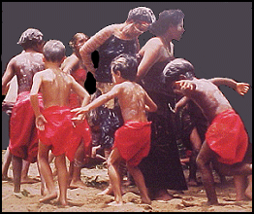  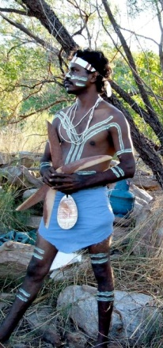  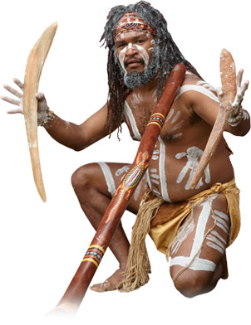  Images from:  http://www.indigenousaustralia.info/culture/corroborees-a-ceremonies.html  http://www.dreamtimetracks.com/images/pages/cultural-centre/hero-image.jpg  http://rendezvous.nols.edu/component/option,com_gallery2/Itemid,574/?g2_itemId=21303  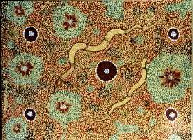 | Making  Making provides students with opportunities to make artworks about different investigations of the world. These are taken up in interpretations of subject matter. Teachers play an important role in assisting students to focus on subject matter and related concepts that are of interest to them and the visual arts. Students also learn about different ways to explore subject matter and learn to use a range of techniques to do this (NSW Board of Studies, 2000).  Appreciating  Appreciating provides students with opportunities to look at, talk about, read about and write about, artists and artworks. Students can think about themselves as members of an audience and recognise that in societies many people are interested in looking at and talking about art. They can explore who Artists/designers/craftspeople/architects are and what they do. The visual arts are integral to the expression of Aboriginal cultural identity and contemporary interpretations of experience. Students can focus on the subject matter of works, the techniques artists use and the meanings that the works may generate, as well as the forms of the works. Over time students can look at how artworks make use of concepts such as perspective, light, dark and abstraction or represent a personal response or the interests of a community. Students can also develop a critical perspective in their appreciation of the visual arts by discussing the properties of selected works and thinking about which is more effective and why. These opportunities also lead to culturally rich and imaginative learning experiences that assist students to enjoy and value the visual arts in their own lives (NSW Board of Studies, 2000).  KLA Links:  - HSIE: Indigenous Culture  - English: Retelling stories of significance.  - Reading, viewing, talking and listening  - Music/ singing, visual arts patterns, lines and shapes  - See Syllabus for outcome codes.  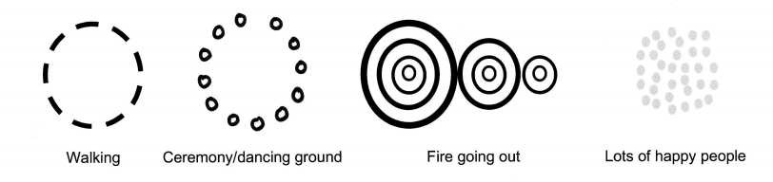  Traditional Symbols  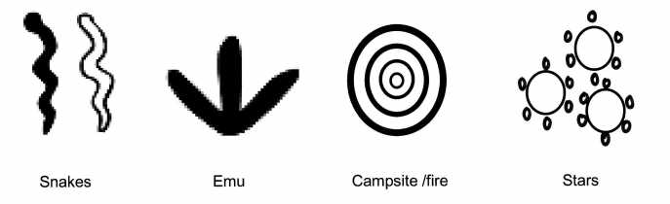  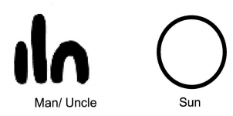  Central Art –Aboriginal Art Store (2007). CA Symbols Handout. Retrieved May 2, 2010, from http://www.aboriginalartstore.com.au
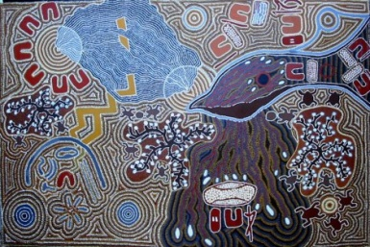
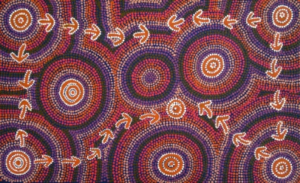
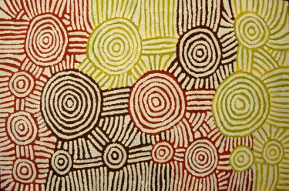

(Marshall Nakamarra, 2006) (Nangala Gallagher, 2008) (Fry, 2010) (Harris, 2010)

Until The Fire Is Out

Let's walk around campfire,

We're eating snake and emu

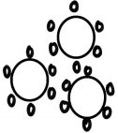
Corroboree lasts all night long, until the sun is up

My Uncle plays the didgeridoo, join in too?

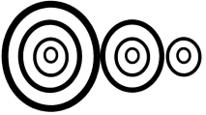

Walk around the campfire, until the fire is out

Note Book/Smart Board Presentation Resource

Visual Arts: Stage 2 year 3

Retelling the song 'Until the Fire Is Out' and making a dance head dress using Aboriginal Symbols

Syllabus Outcomes & Leaning Focus or Indicators:

Making
VAS2.1 Represents the qualities of experiences and things that are interesting or beautiful by choosing among aspects of subject matter: Seeks to investigate traditions in art suited to different subject matter, the use of Indigenous symbols (most being from Wiradjuri Country) and uses these in their art making.
VAS2.2 Uses the forms to suggest the qualities of subject matter: Experiments with techniques in painting, drawing and uses the artistic concepts of patterns, colour, line and bird’s eye view perspective, to explore how symbols may be used in their interpretation of selected subject matter.
Appreciating
VAS2.4 Identifies connections between subject matter in artworks and what they refer to, and appreciates the use of particular techniques: Identifies Indigenous symbols in painted arts works.

KLA Links: HSIE, English, Music & PDHPE,

Created By Kathryn Gersbach 11377923

Traditional Paintings
This page is for students to identify colour, shape and line and go on a virtual tour of an Indigenous art gallery.
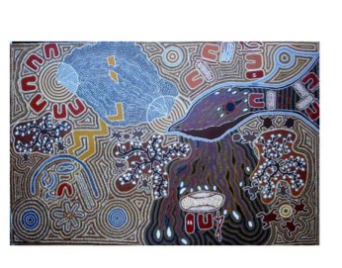
http://www.aboriginalartshop.com/

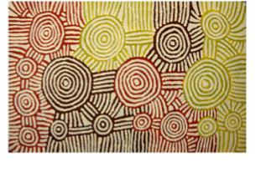

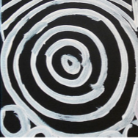

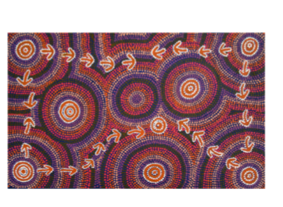
Fry, M. (2010). Rainwater Dreaming Marshall Nakamarra, K. (2006).
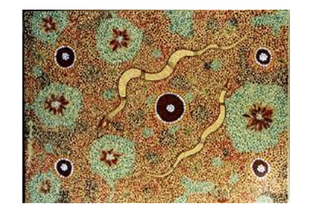
Woman’s ceremony

Harris, E. (2010). Snakes Nangala Gallagher, M. (2008). Emu Dreaming

Traditional Symbols used in Aboriginal Paintings
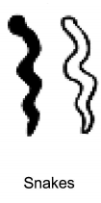
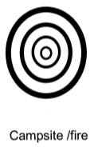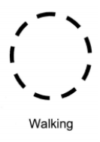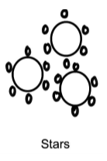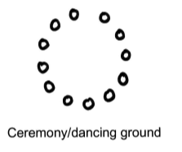
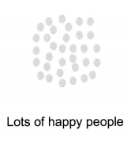
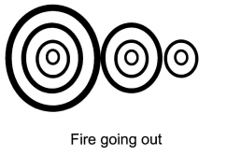

This page is for students learn some traditional symbols found in the paintings.

Until The Fire Is Out
This page is for students to retell the events in the song using symbols.
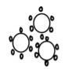
Let's walk around campfire,

We're eating snake and emu

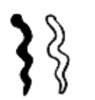
Corroboree lasts all night long, until the sun is up
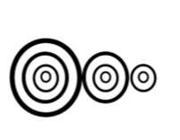
My Uncle plays the didgeridoo, we all join in too?

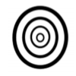
Walk around the campfire, until the fire is out

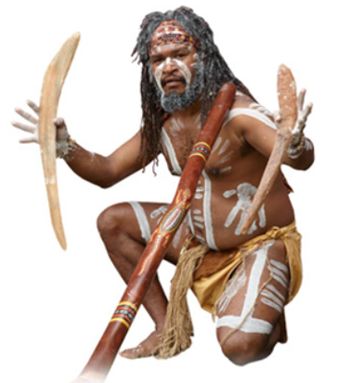
Traditional Aboriginal and Torres Strait Islander head and dance dress
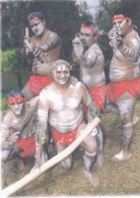
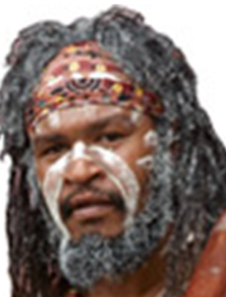
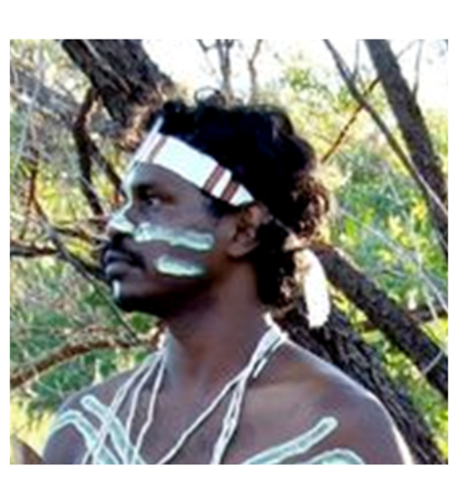
This page is for students to identify symbols on headbands.

Drawing and Painting:
A recount of the events in the song using symbols.

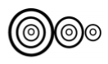
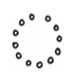

Walking Campfire Snakes Emu Corroboree Stars Sun Man People Walking Fire going out

This page is for students to practice their symbol drawing skills.

Until The Fire Is Out

Let's walk around the campfire,

We're eating snake and emu

Corroboree lasts all night long, until the sun is up

My Uncle plays the didgeridoo, join in too?

Walk around the campfire, until the fire

References/Bibliography

Aboriginal Art Shop (2010). Retrieved May 2, 2010, from http://www.aboriginalartshop.com/

Central Art –Aboriginal Art Store (2007). CA Symbols Handout. Retrieved May 2, 2010, from http://www.aboriginalartstore.com.au

Fry, M. (2010). Rainwater Dreaming. Retrieved May 2, 2010, from http://www.bushcrafts.com.au/Aboriginal_Paintings.html

Harris, E. (2010). Snakes. Retrieved May 2, 2010, from http://www.albury.net.au/tim/chdomal12.htm

Kinghom, O. (2009). Teaching Aboriginal art: Australian Aboriginal dot painting. Retrieved September 16th 2009, from http://ezinearticles.com/?Teaching-Aboriginal-Art

Marshall Nakamarra, K. (2006). Woman’s Ceremony. Retrieved May 2, 2010, from http://www.artery.com.au/painting.php?catalogue=2006

Nangala Gallagher, M. (2008). Emu Dreaming. Retrieved May 2, 2010, from http://www.artery.com.au/painting.php?catalogue=135508

NSW Board of Studies. (2000). Creative Arts K-6: Syllabus. Sydney: NSW Board of Studies. Retrieved March, 2007, from http://www.k6.boardofstudies.nsw.au/go/creativearts/

Strong, D. (2006). Focus on indigenous art: Across curriculum. Sydney: Macmillan Education Australia.

8 Aboriginal Ways of Learning, (2010). Retrieved March 2, 2010, from http://8ways.wikispaces.com/

8 Aboriginal Ways of Learning, (2010). Retrieved March 2, 2010, from http://8ways.wikispaces.com/

